**CHAPTER 1**

**INTRODUCTION**

**1.1 PROBLEM DEFINITION**

Social organizing websites permit clients to talk with individuals, share thoughts, exercises, occasions, and interface interior their person systems. Social community locales like MySpace, Facebook, Orkut, and Google+ have pulled in army clients, numerous of whom have coordinates these websites into their day by day hones. There are numerous Social Organizing Destinations, with a run of innovative affordances, helping a rectify shift of interface and jones. Locales to change inside the degree to which they contain modern information and verbal trade apparatuses, like cellular network, blogging, and photo/video-sharing.

**1.1.1 OBJECTIVES**

The objective of the project is to explain and elaborate the concept of “Social Networking Sites” to the users, hence providing a reliable and efficient sharing of ideas, thoughts and creativity online so as to assist users to afford it without much trouble.

* To have attractive and Secure Login page to access
* Make new user accounts in more user friendly and proper validation of details.
* Username and password will be asked to repeat for a strong and secure user account access.
* Creating a public profile having social, and personal information.
* Upload and Share Images or videos on network which has posted timestamp
* Ease of editing and uploading profile and cover images
* Maintain separate set of private images which can also be deleted later
* Comment on the posts and also can delete the comments, it also has a timestamp on when it is commented.

**CHAPTER 2**

**FUNDAMENTALS OF WEB FRAMEWORKS TECHNOLOGIES**

**2.1 INTRODUCTION TO INTERNET**

The web may be a worldwide organize that interfaces different gadgets and sends lots of information and media. It employs an internet Convention (IP) and Transport Control Convention (TCP)-based bundle steering arrangement. TCP and IP work together to affirm that information transmission over the net is reliable and dependable, no matter the gadget or area. Information is conveyed over the net inside an assortment of messages and parcels. A message may be a bit of data conveyed over the net, but some time recently when it's sent, it's debilitated into little pieces called packets. IP can be a set of rules that control how information is transmitted from one computer to another through the net. The IP framework gets advanced enlightening on how the information ought to be exchanged utilizing a numerical address (IP Address). The TCP is utilized with IP to affirm that information is exchanged in an exceedingly secure and dependable way.

**2.2 WORLD WIDE WEB**

World Wide Web (WWW), byname the Web, the leading data retrieval carrier of the Internet (the worldwide pc network). The Web gives users get admission to to a widespread array of files that are linked to every other by means of capability of hypertext or hypermedia links—i.e., hyperlinks, digital connections that link related portions of information in order to allow a person handy access to them. Hypertext allows the consumer to pick a word or phrase from textual content and thereby get entry to different archives that comprise extra facts pertaining to that word or phrase. Hypermedia documents feature hyperlinks to images, sounds, animations, and movies.



**Figure 2.1: World Wide Web**

**2.3 WEB BROWSER**

The web browser is a software program to discover www (World Wide Web). It gives an interface between the server and the client and requests to the server for internet documents and services. It works as a compiler to render HTML which is used to sketch a webpage. Whenever we search something on the internet, the browser sends hundreds of pages to an internet page written in HTML, along with text, links, images, and different gadgets such as fashion sheets and JavaScript functions. Google Chrome, Microsoft Edge, Mozilla Firefox, Safari are examples of internet browsers.

**2.4 OPERATION OF WWW**

1. User enters the URL (say, http://www.tutorialspoint.com) of the internet page in the tackle bar of web browser.
2. Then browser requests the Domain Name Server for the IP tackle corresponding to www.tutorialspoint.com.
3. After receiving IP address, browser sends the request for internet page to the internet server the use of HTTP protocol which specifies the way the browser and net server communicates.
4. Then internet server receives request the usage of HTTP protocol and tests its search for the requested net page. If determined it returns it lower back to the web browser and close the HTTP connection.
5. Now the internet browser receives the internet page, It interprets it and display the contents of web web page in internet browser’s window.

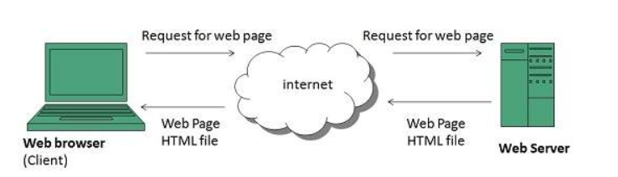

**Figure 2.2: World Wide Web Operation**

**2.5 WEB 2.0**

When it comes to defining net 2.0. the time period capability such internet functions which permit sharing and collaboration possibilities to humans and assist them to express themselves online.

It’s a honestly extended version of the first international web, characterised specially through the exchange from static to dynamic or user-generated content material and additionally the increase of social media.

The concept in the back of Web two refers to prosperous web applications, web-oriented architecture, and social web. It refer to modifications in the approaches net pages are designed and used by means of the users, barring any alternate in any technical specifications.

**2.6 HTML**

HTML stands for HyperText Markup Language. It is utilized to chart web pages the utilization of a markup dialect. HTML is the combination of Hypertext and Markup dialect. Hypertext characterizes the hyperlink between the net pages. A markup dialect is utilized to characterize the printed substance archive interior tag which characterizes the structure of web pages. This dialect is utilized to explain (make notes for the computer) printed substance so that a tablet can get it it and control content appropriately. Most markup dialects (e.g. HTML) are human-readable. The dialect makes utilize of labels to characterize what control has got to be achieved on the text. HTML could be a markup dialect utilized by utilizing the browser to control content, pictures, and distinctive substance, in arrange to show it within the required organize. HTML utilized to be created by Tim Berners-Lee in 1991. The first-ever form of HTML utilized to be HTML 1.0, but the primary prevalent demonstrate was HTML 2.0, posted in 1995.

**2.7 HTML TAGS**

| Tag | Type | What It Is |
| --- | --- | --- |
| <p> | HTML Text Tags | Paragraph |
| <h1> | HTML Text Tags | Heading 1 |
| <h2> | HTML Text Tags | Heading 2 |
| <h3> | HTML Text Tags | Heading 3 |
| <h4> | HTML Text Tags | Heading 4 |
| <h5> | HTML Text Tags | Heading 5 |
| <h6> | HTML Text Tags | Heading 6 |
| <strong> | HTML Text Tags | Strong |
| <em> | HTML Text Tags | Emphasis |
| <abbr> | HTML Text Tags | Abbreviation |
| <address> | HTML Text Tags | Contact Information |
| <bdo> | HTML Text Tags | Override The Current Text Direction |
| <blockquote> | HTML Text Tags | Content From Another Source |
| <cite> | HTML Text Tags | Title Of The Work, Book, Website |
| <q> | HTML Text Tags | Inline Quotation |
| <code> | HTML Text Tags | Display A Part Of Programming Code |
| <ins> | HTML Text Tags | Text Inserted |
| <del> | HTML Text Tags | Text Deleted From The Document |
| <dfn> | HTML Text Tags | Term Defined Within A Sentence/Phrase |
| <pre> | HTML Text Tags | Preformatted Text |
| <samp> | HTML Text Tags | Sample Output Of A Computer Program |
| <var> | HTML Text Tags | Variable Name Used In Mathematical Or Programming Context |
| <br> | HTML Text Tags | Single Line Break |
| <div> | HTML Text Tags | Division |
| <a> | HTML Link Tags | Anchor Tag For A Link |
| <base> | HTML Link Tags | Base Url For All Relative Url Within The Document |
| <img> | HTML Image And Object Tags | Image |
| <area> | HTML Image And Object Tags | Area Of An Image Map |
| <map> | HTML Image And Object Tags | Image Map |
| <param> | HTML Image And Object Tags | Parameter For An <Object> Element |
| <object> | HTML Image And Object Tags | Embed An Object |
| <ul> | HTML List Tags | Unordered List |
| <ol> | HTML List Tags | Ordered List |
| <li> | HTML List Tags | List |
| <dl> | HTML List Tags | Description List |
| <dt> | HTML List Tags | Term In Description List |
| <dd> | HTML List Tags | Definition/Description Of A Term In Description List |

**Table 2.1: HTML Tags**

**2.8 XHTML**

Extensible HyperText Markup Language (XHTML) is the stage of the family of XML markup dialects. It mirrors or amplifies adaptations of the broadly utilized HyperText Markup Dialect (HTML), the dialect in which Web pages are formulated. While HTML, earlier to HTML5, was once characterized as an program of Standard Generalized Markup Dialect (SGML), a flexible markup dialect system, XHTML is an utility of XML, an additional prohibitive subset of SGML. XHTML records are well-formed and may also subsequently be parsed the utilization of far reaching XML parsers, in order to differentiate HTML, which needs a tolerant HTML-specific parser. XHTML 1.0 got to be a World Wide Web Consortium (W3C) counsel on 26 January 2000. XHTML 1.1 developed to be a W3C proposal on 31 May 2001. The style respected as XHTML5 is being created as an XML adjustment of the HTML5 specification.

**2.9 CSS**

Cascading Style Sheets, fondly referred to as CSS, is a genuinely designed language intended to simplify the method of making internet pages presentable. CSS permits you to follow styles to internet pages. More importantly, CSS allows you to do this impartial of the HTML that makes up each web page. It describes how a webpage must look: it prescribes colors, fonts, spacing, and an awful lot more. In short, you can make your internet site seem to be however you want. CSS lets developers and designers outline how it behaves, consisting of how elements are positioned in the browser.

**2.10 PHP**

PHP(short for Hypertext PreProcessor) is the most widely used open supply and everyday cause server facet scripting language used frequently in net development to create dynamic websites and applications. It was once developed in 1994 by using Rasmus Lerdorf. A survey via W3Tech shows that almost 79% of the websites in their records are developed using PHP.PHP can simply do whatever associated to server-side scripting or more popularly known as the backend of a website. There are also many hash features on hand in PHP to encrypt user’s facts that makes PHP tightly closed and reliable to be used as a server-side scripting language.

**CHAPTER 3**

**REQUIREMENT SPECIFICATIONS**

**3.1 HARDWARE REQUIREMENTS**

* Operating System: Windows XP/ Windows 7/ Linux
* Processor Name: Dual Core
* Processor Speed: 3.2 GHz
* RAM: 1 GB
* Hard Disk Capacity: 80 GB
* Display Device: 14’ to 19’ InchMonitor
* Keyboard Type: PS2 or USB
* Mouse Type: PS2 or USB

**3.2 SOFTWARE REQUIREMENTS**

* Technology Implemented: Apache Server
* Language Used: PHP 5.2
* Database: My SQL 5.2
* User Interface Design: HTML, AJAX
* Web Browser: Mozilla,IE8
* Programming Language: PHP
* Software: XAMPP Server

**CHAPTER 4**

**DESIGN**

**4.1 WEBSITE STRUCTURE**

1. The Index page takes you to an interface for Sign in and Sign up.
2. If you do not have an account already, you must sign up by providing the required entries asked in the sign up section.
3. Once your account is being created after successful entry in every sign up fields, you can sign in using the provided gmail and password
4. After successful login, it takes you to the home page, where you can view all the posts and comments by other users.
5. There will be your username, home, profile, photos and log out options in the top navigation bar.
6. Your username option takes you to a page where you can post photos or videos with a caption, edit profile picture and cover picture. You can also delete the post if not needed.
7. Every post and comment will be holding a timestamp of its details of when it is posted.
8. The profile option takes you to edit profile page where you can edit the previously fed information and also the profile picture.
9. The photos option takes you to the page where you can post photos or videos which are private and cannot be seen by others, it can also be deleted if not needed.
10. The Log out option, signs off your account and takes you back to index page which consists of Sign in and Sign up options.

**CHAPTER 5**

**IMPLEMENTATION**

**5.1 PHP CODES**

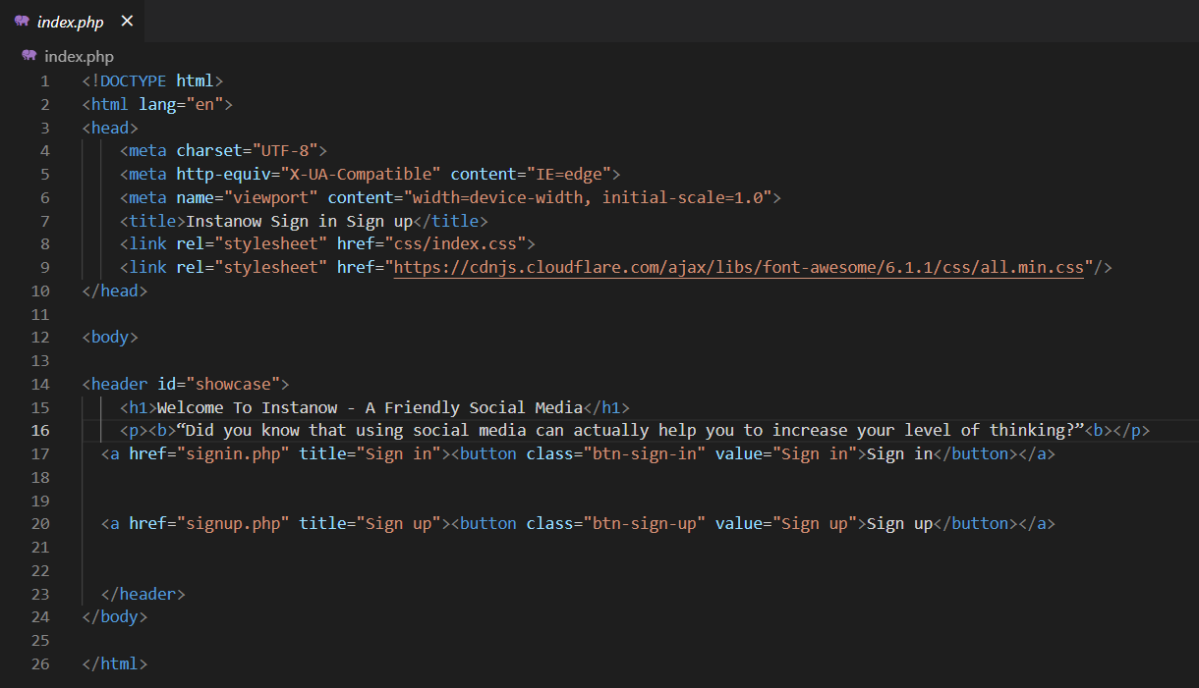

**Figure 5.1: INDEX.PHP**

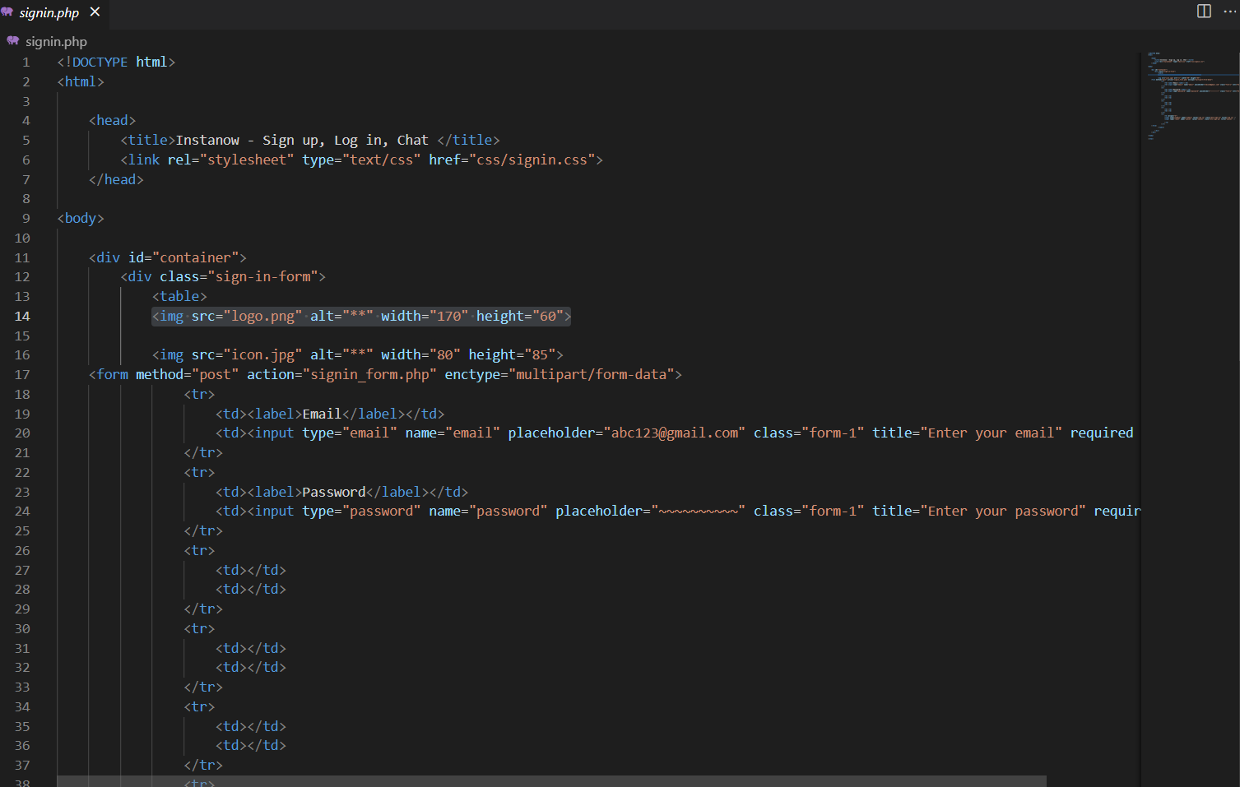

**Figure 5.2: SIGNIN.PHP**

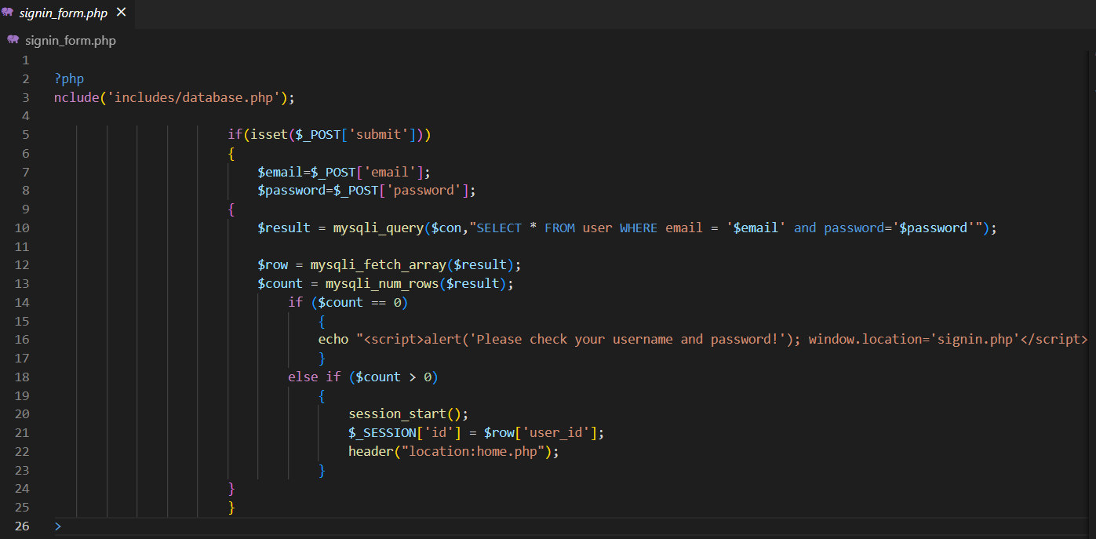

**Figure 5.3: SIGNIN_FORM.PHP**

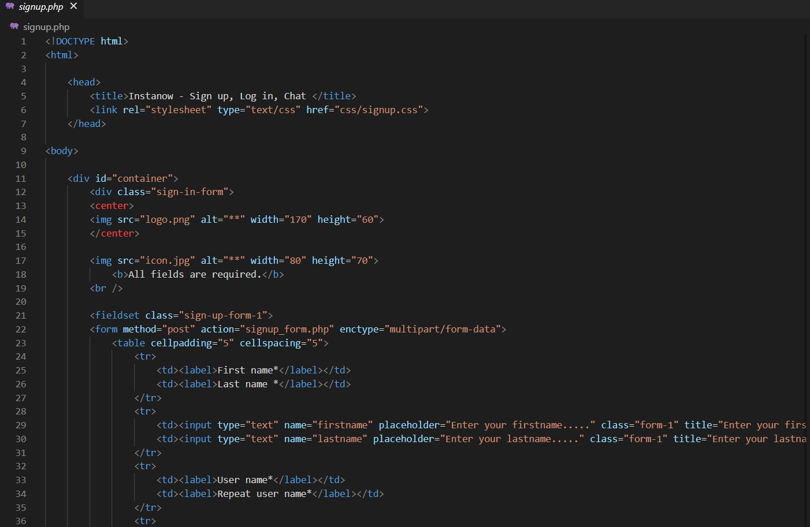

**Figure 5.4: SIGNUP.PHP**

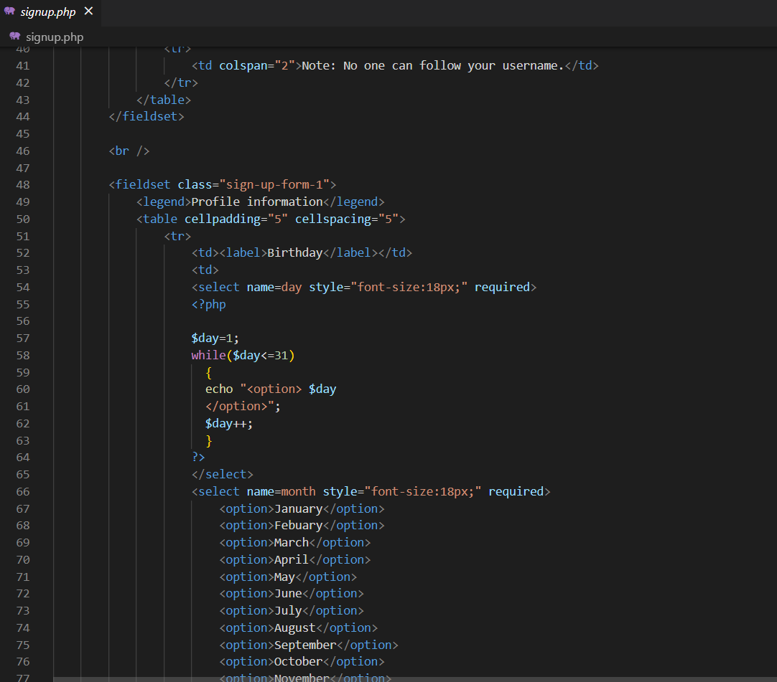

**Figure 5.5: SIGNUP.PHP**

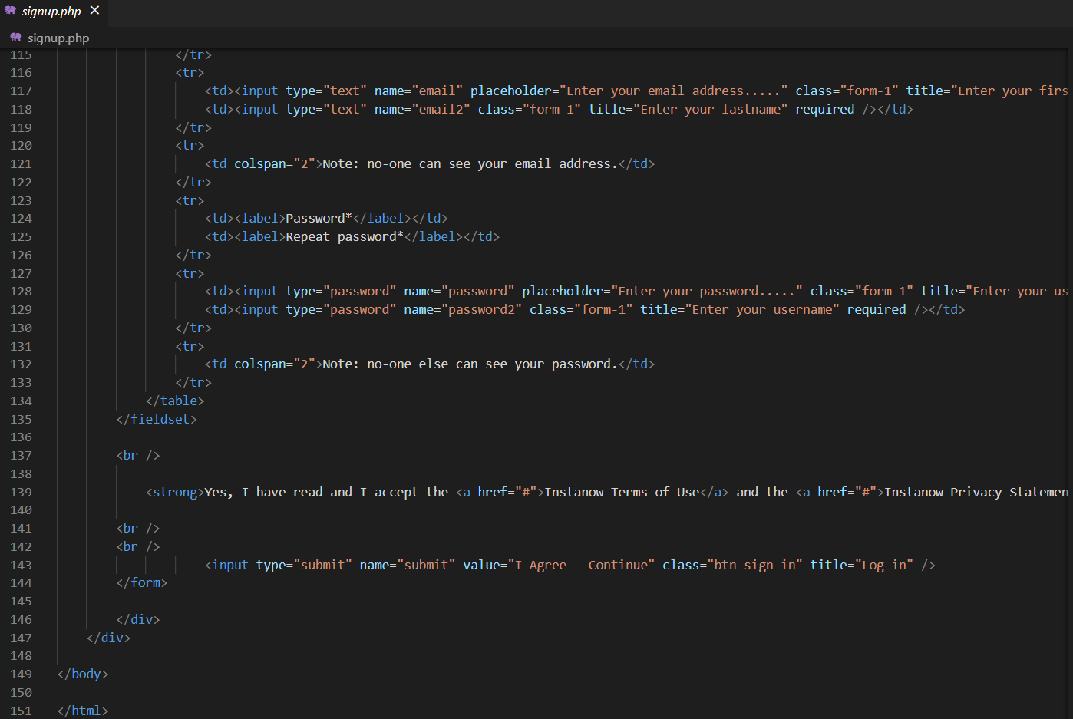

**Figure 5.6: SIGNUP.PHP**

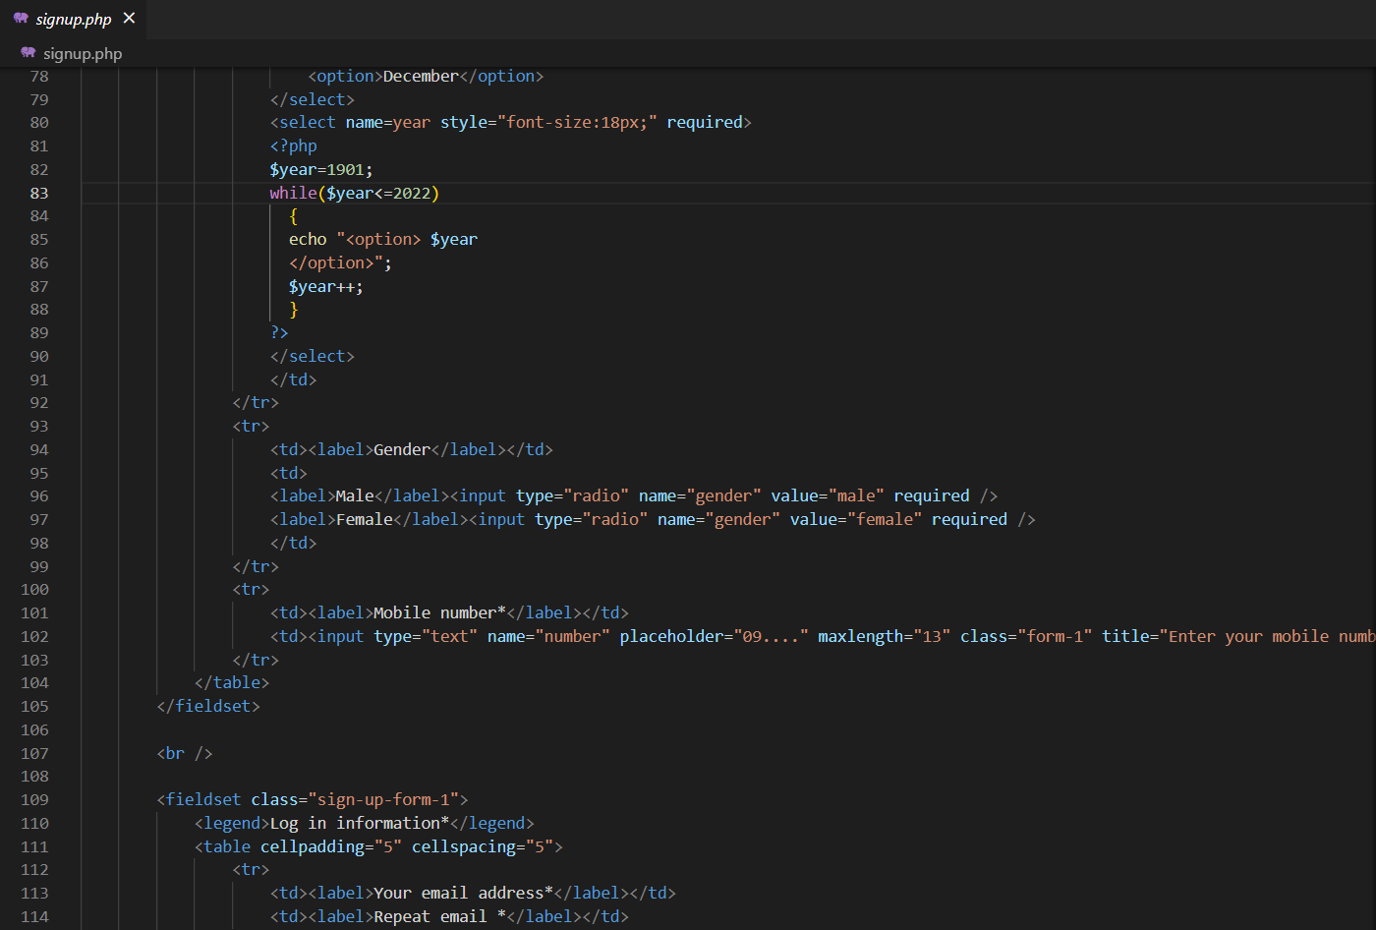

**Figure 5.7: SIGNUP.PHP**

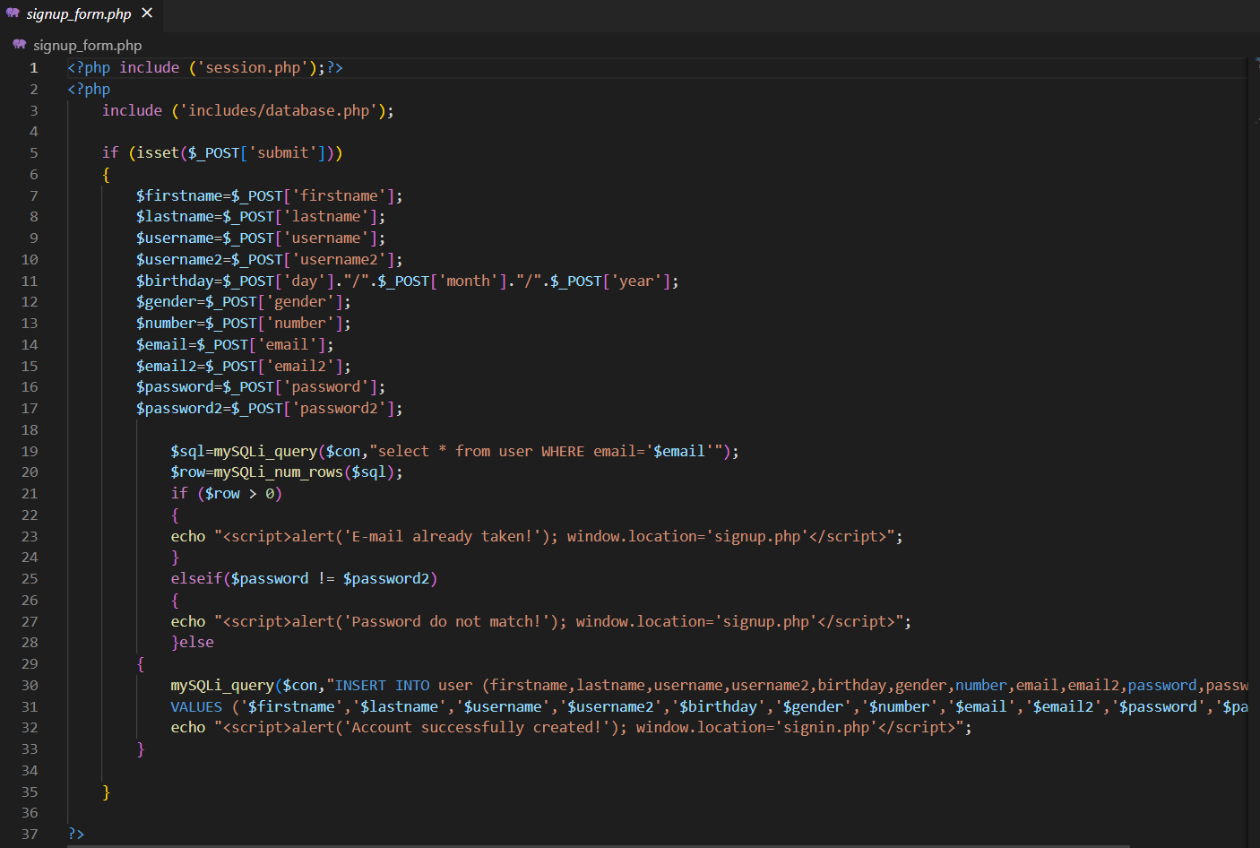

**Figure 5.8: SIGNUP_FORM.PHP**

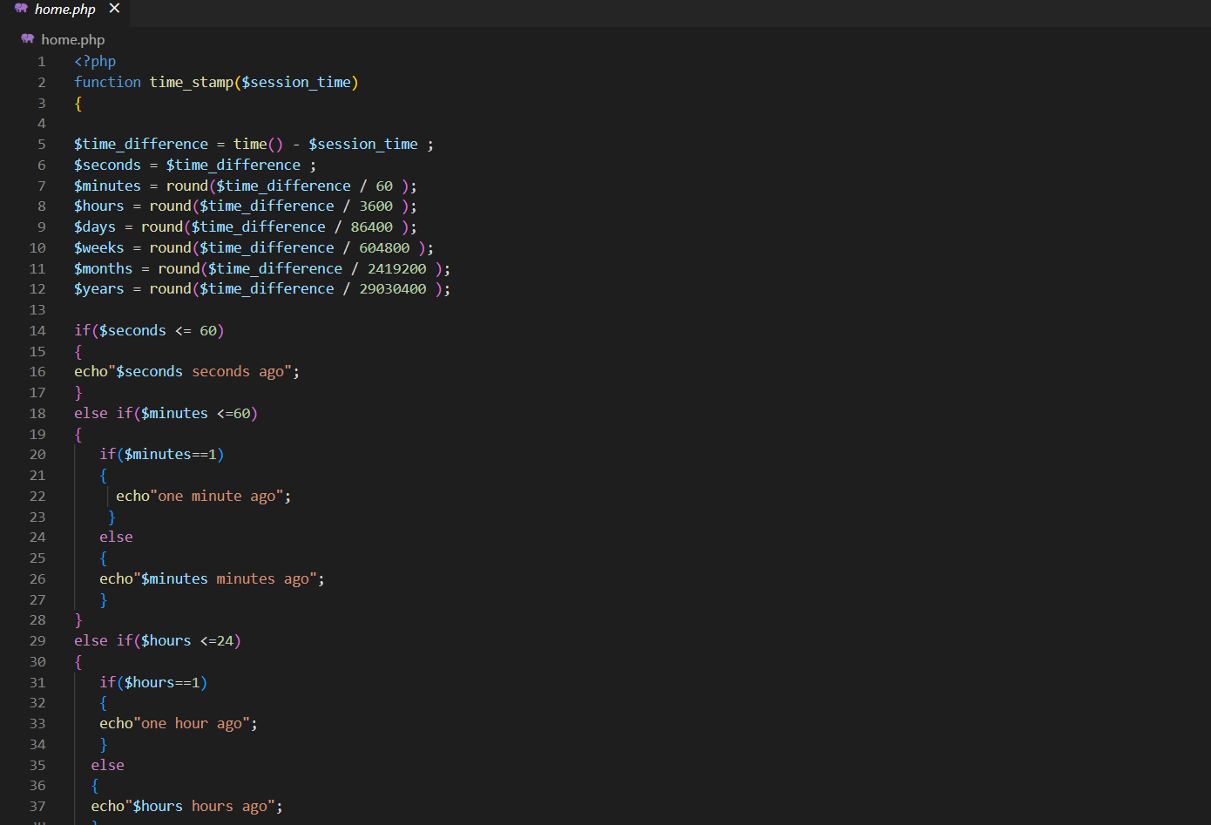

**Figure 5.9: HOME.PHP**

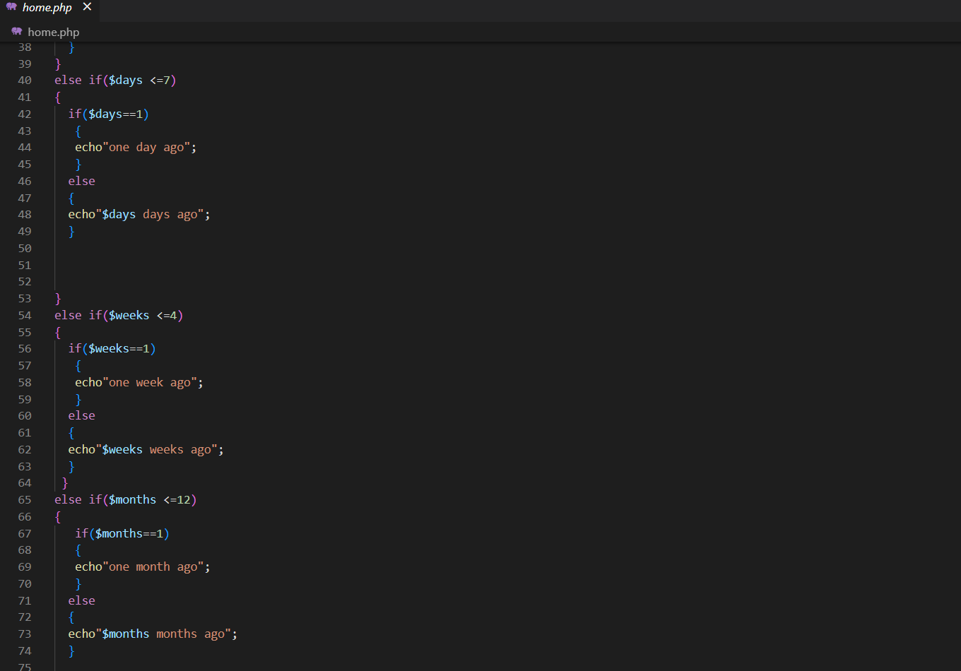

**Figure 5.10: HOME.PHP**

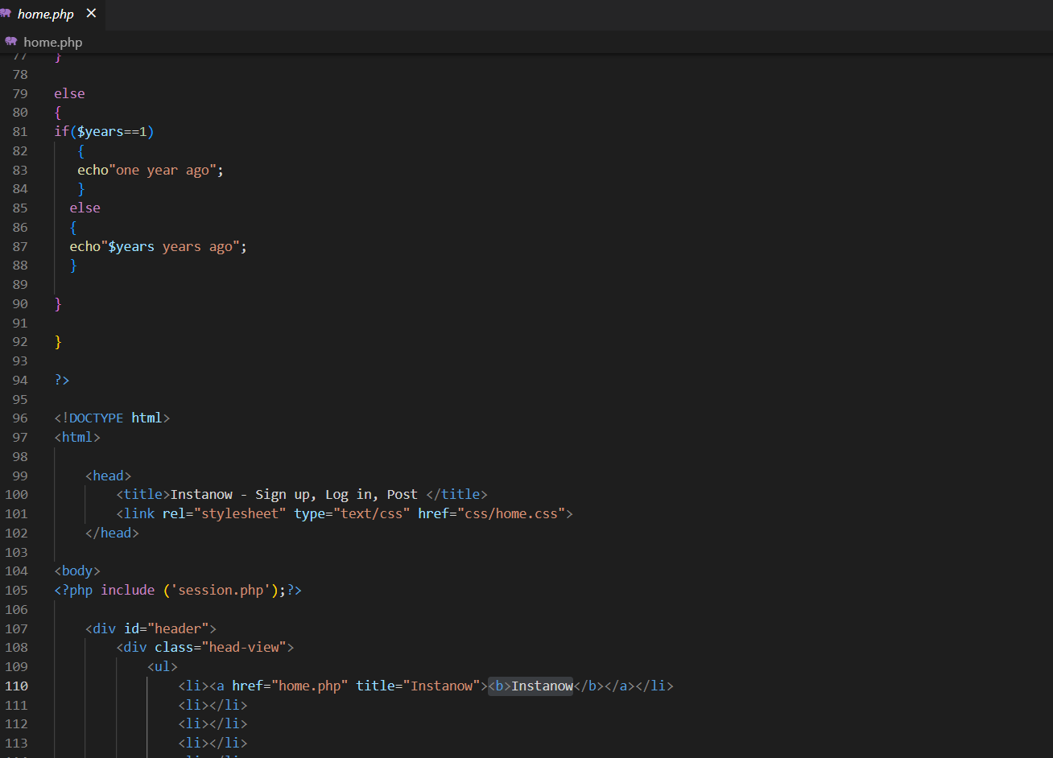

**Figure 5.11: HOME.PHP**

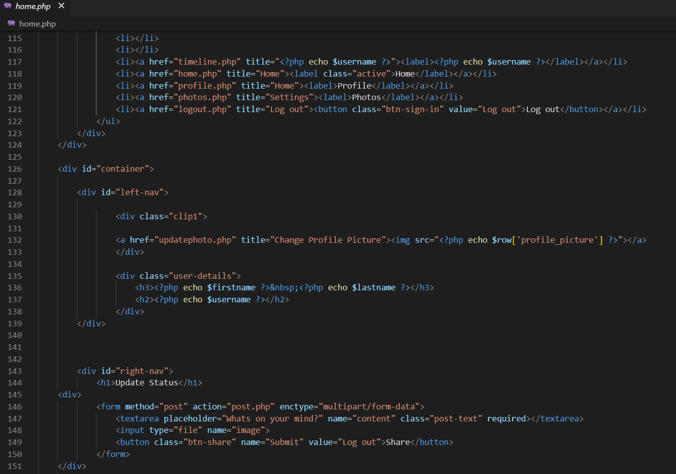

**Figure 5.12: HOME.PHP**

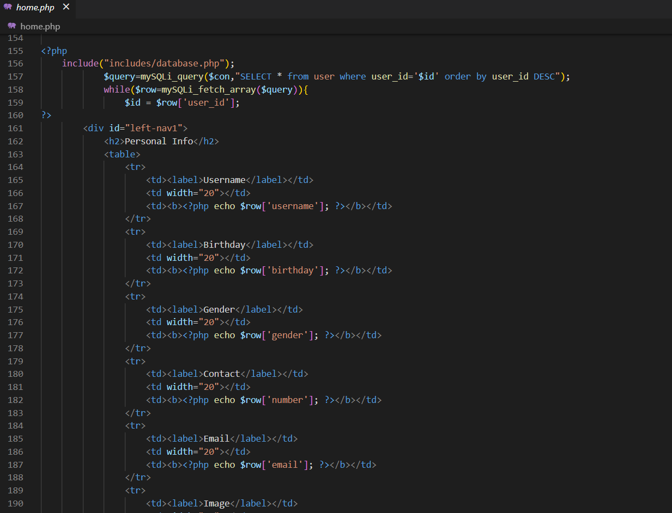

**Figure 5.13: HOME.PHP**

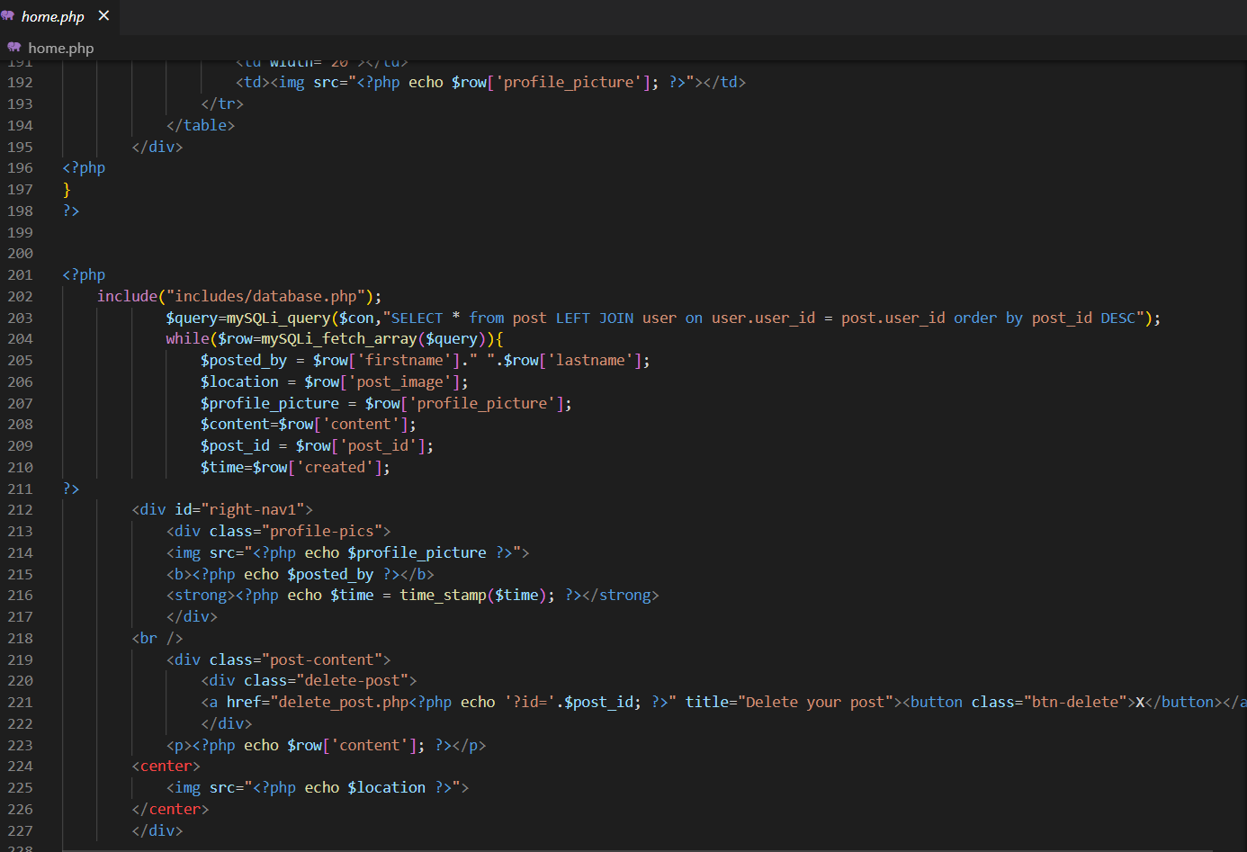

**Figure 5.14: HOME.PHP**

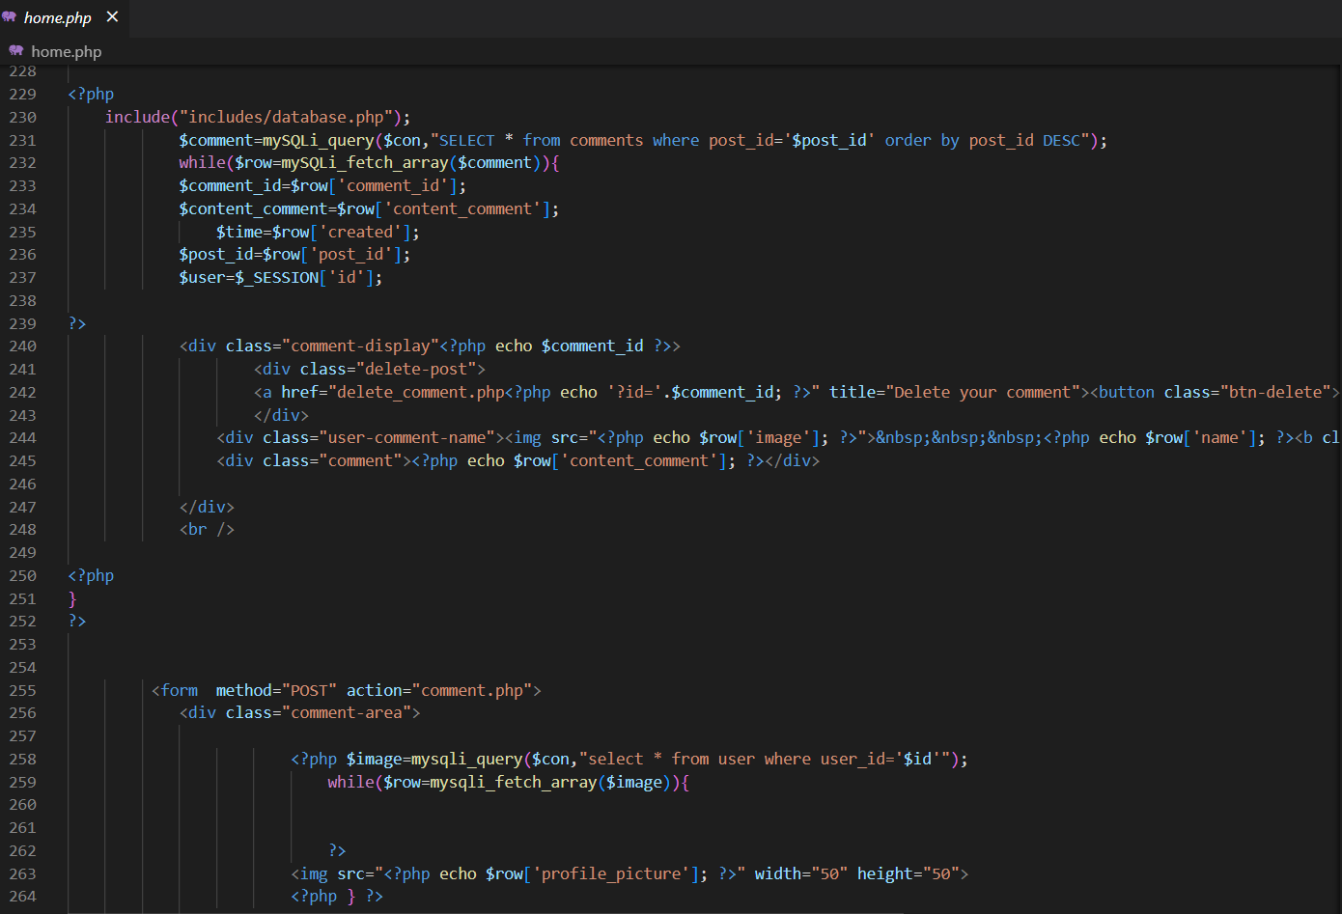

**Figure 5.15: HOME.PHP**

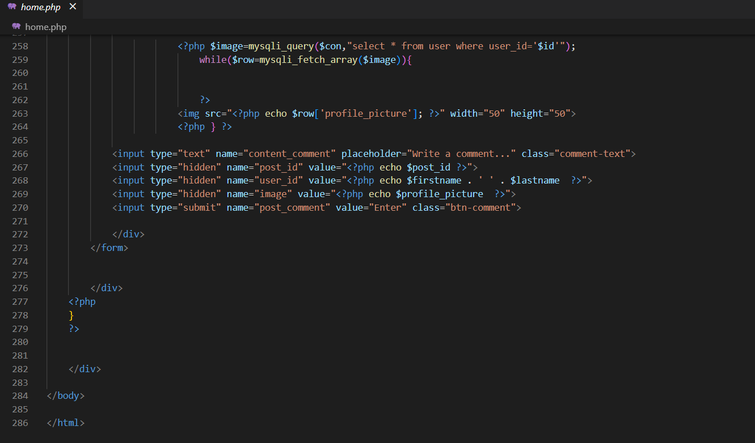

**Figure 5.16: HOME.PHP**

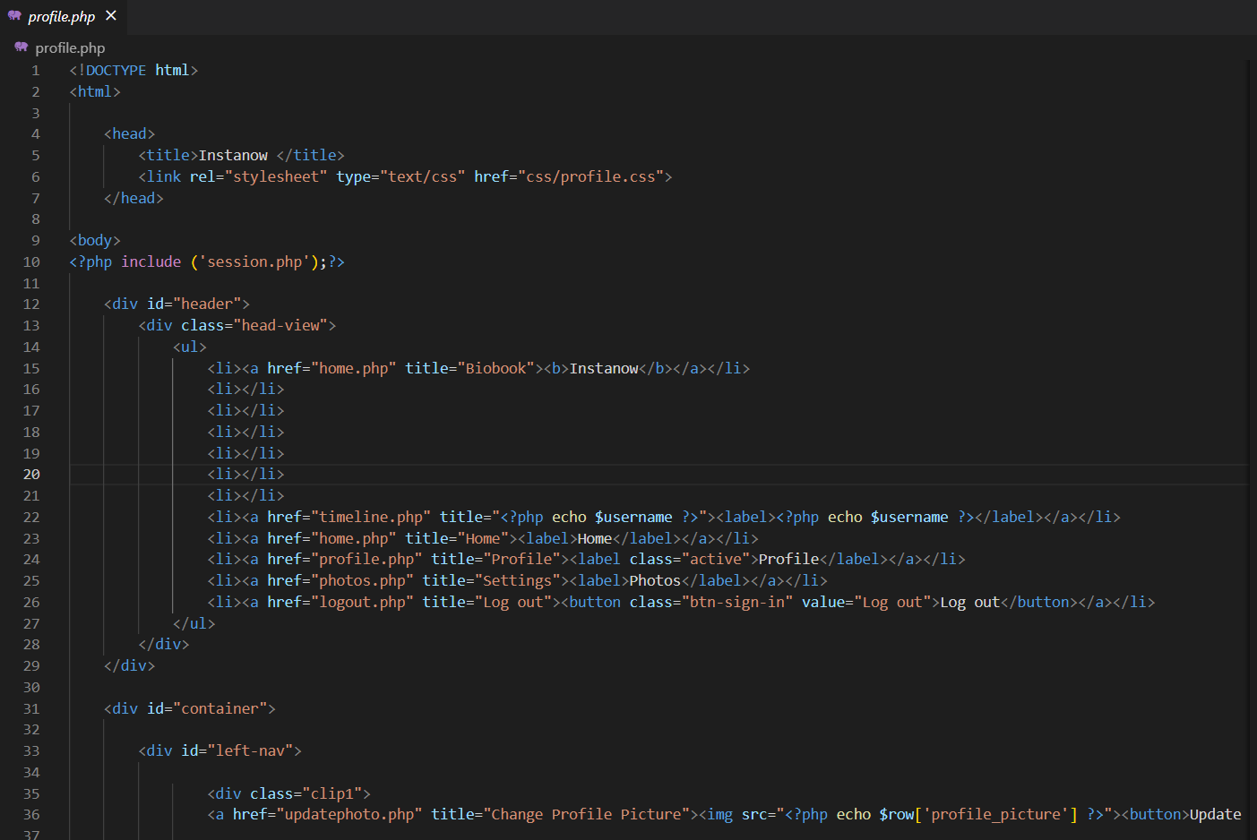

**Figure 5.17: PROFILE.PHP**

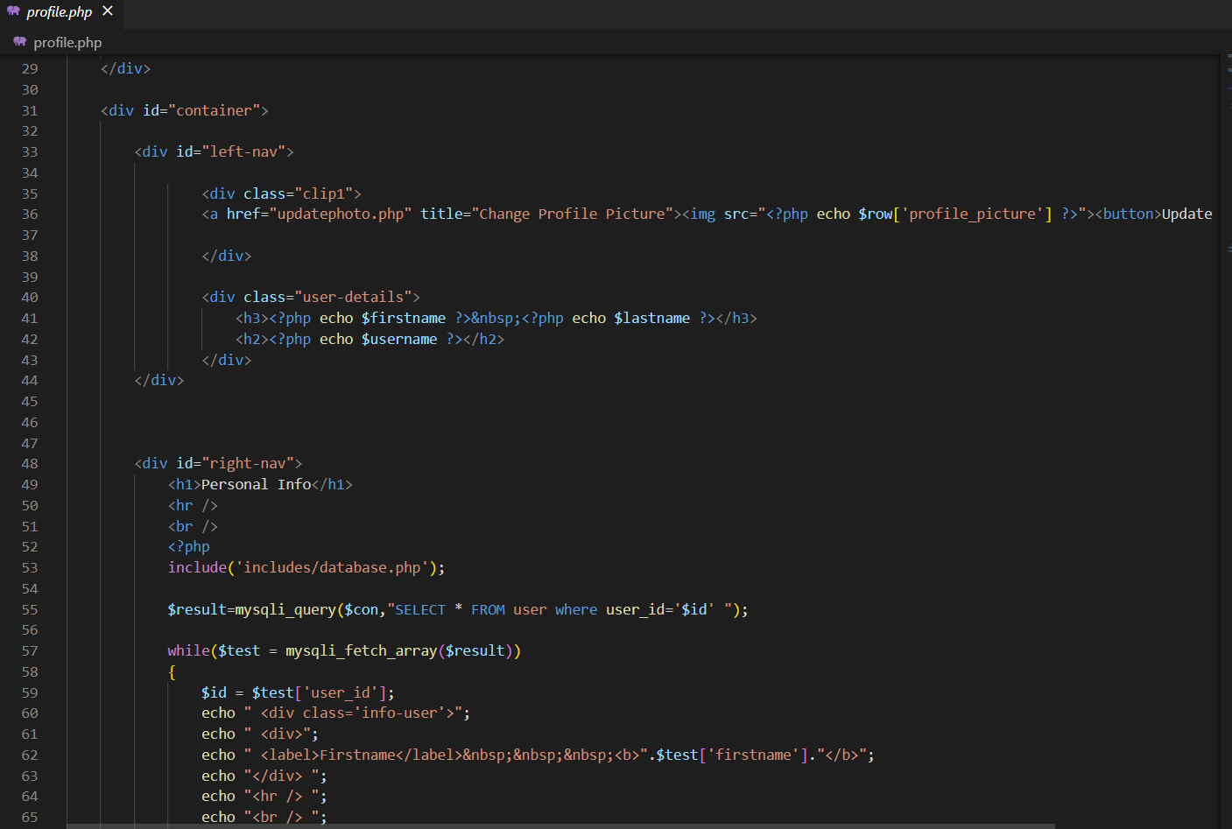

**Figure 5.18: HOME.PHP**

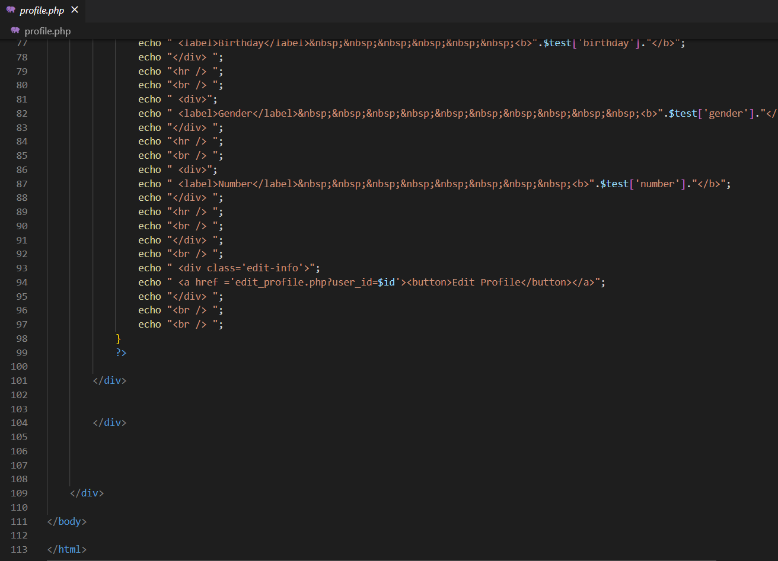

**Figure 5.19: HOME.PHP**

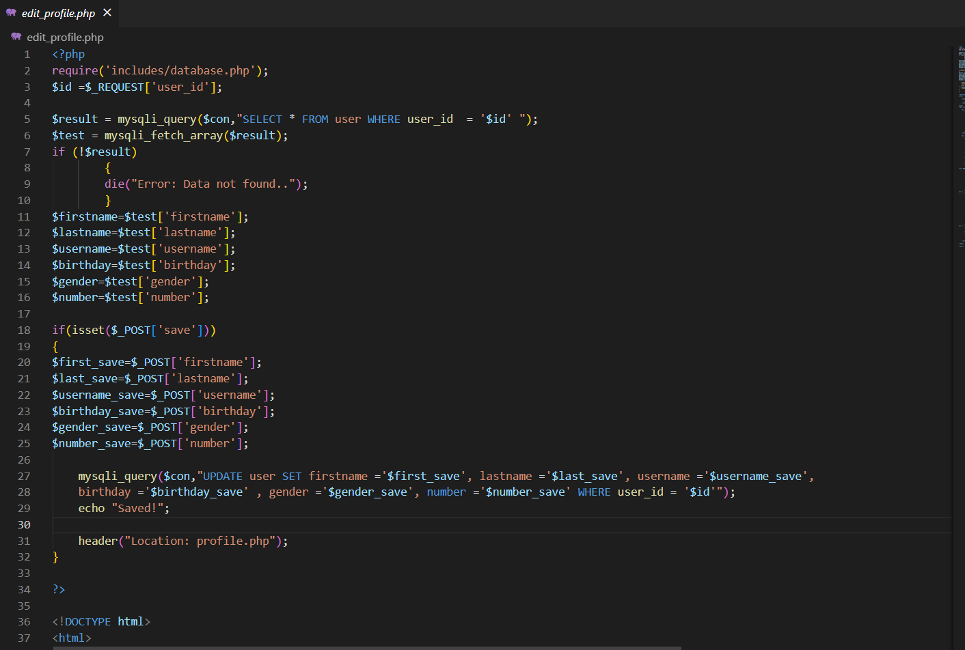

**Figure 5.20 EDIT_PROFILE.PHP**

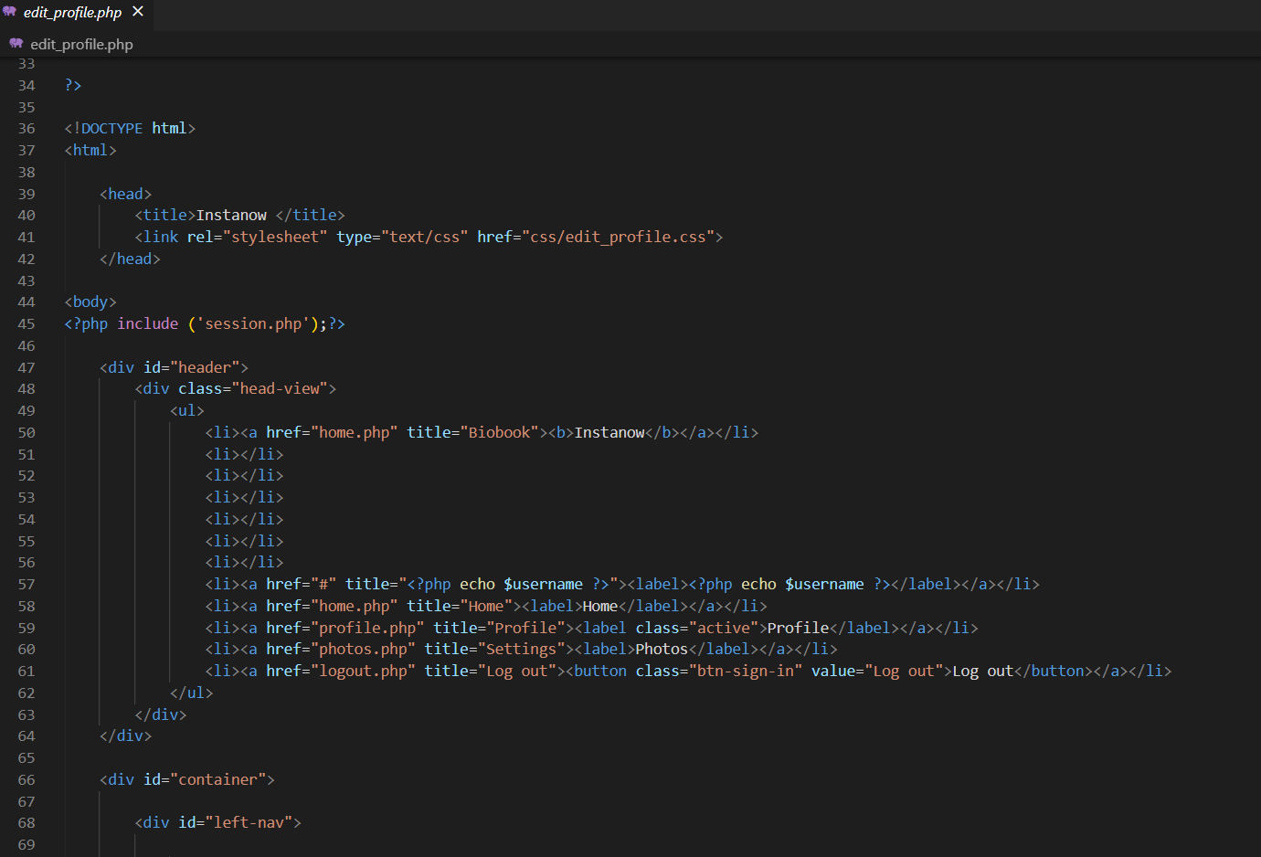

**Figure 5.21 EDIT_PROFILE.PHP**

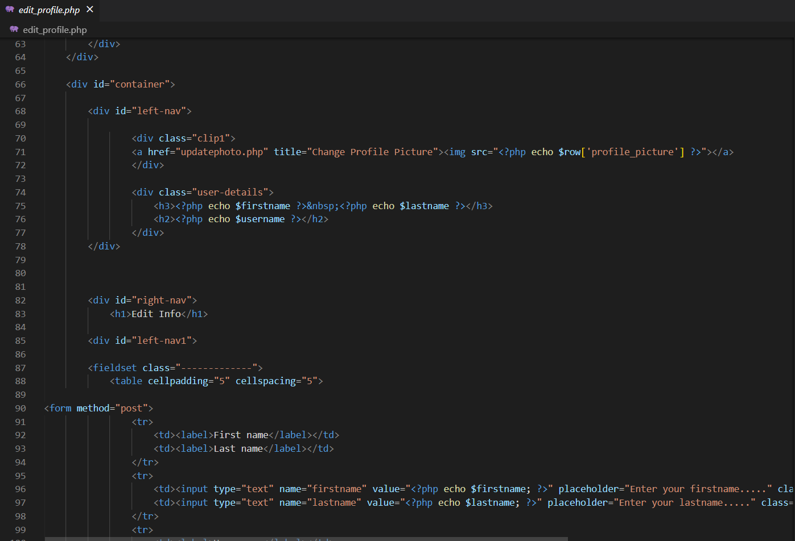

**Figure 5.22 EDIT_PROFILE.PHP**

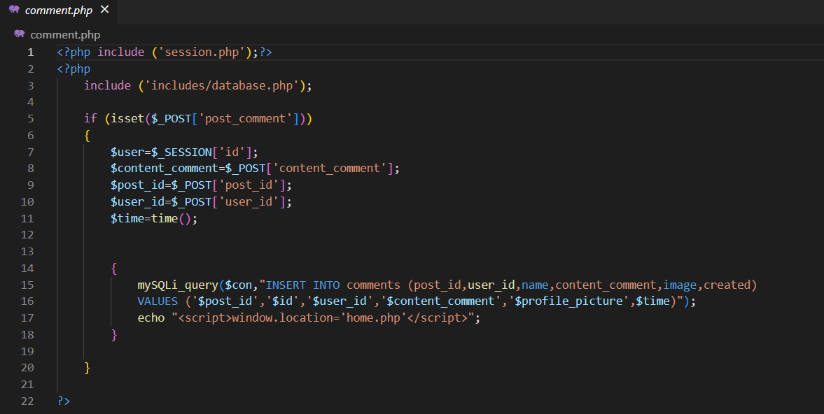

**Figure 5.23 COMMENT.PHP**

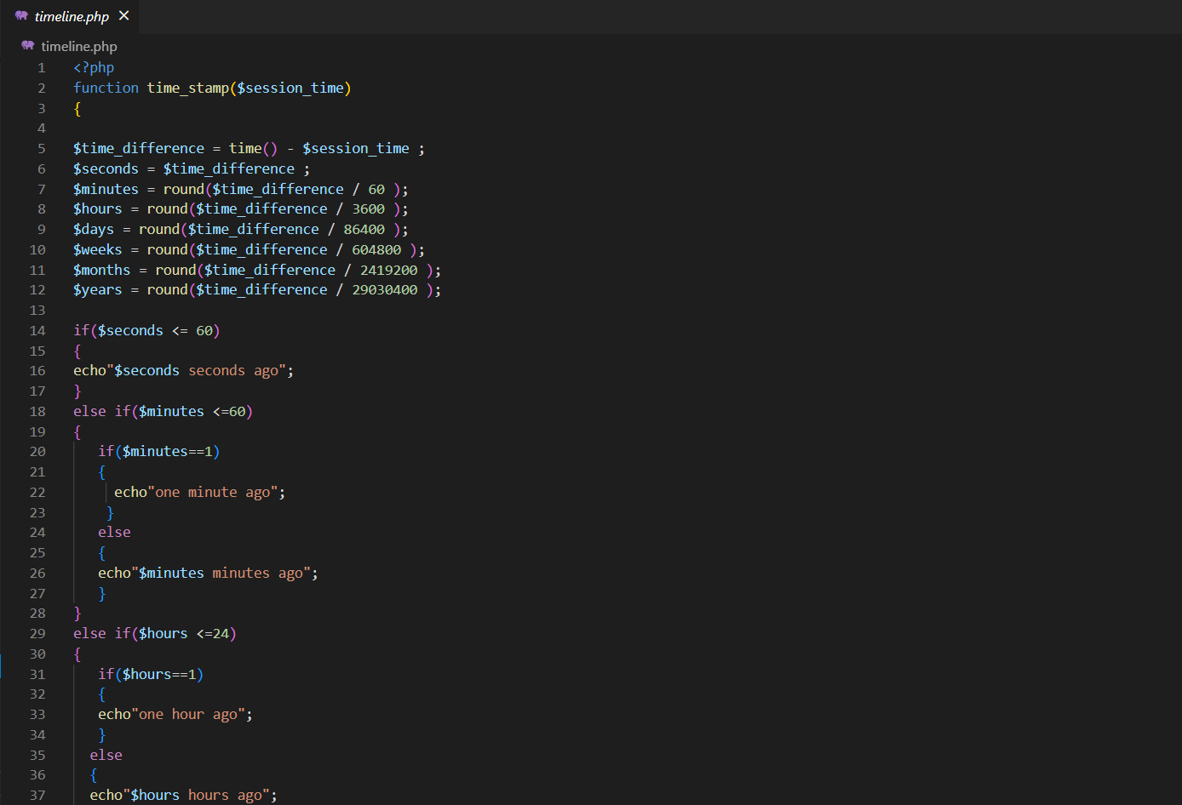

**Figure 5.24 TIMELINE.PHP**

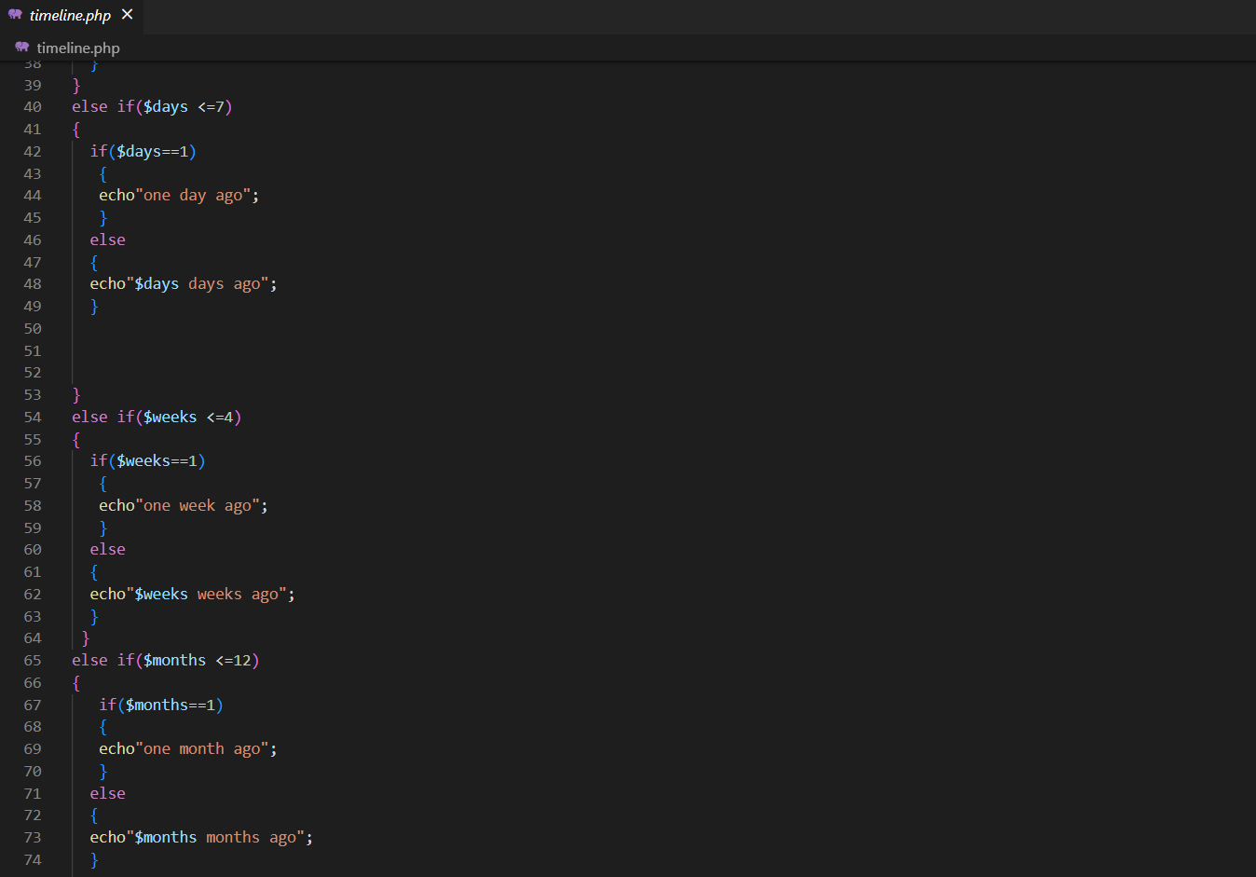

**Figure 5.25 TIMELINE.PHP**

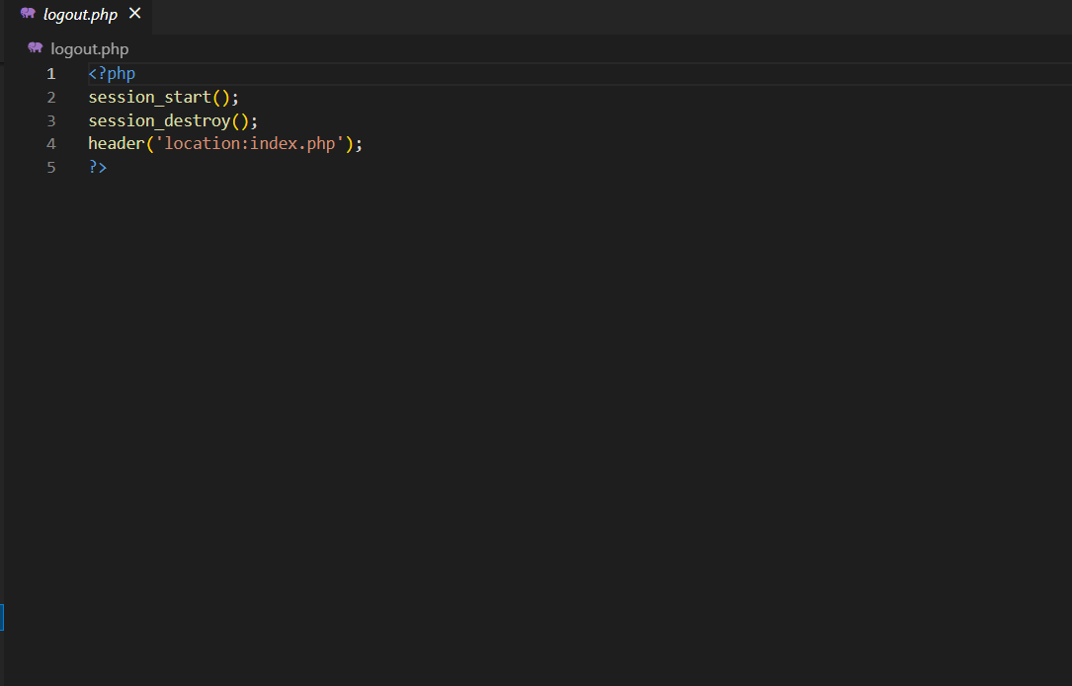

**Figure 5.26 LOGOUT.PHP**

**CHAPTER 6**

**RESULTS**

**6.1 INDEX PAGE**

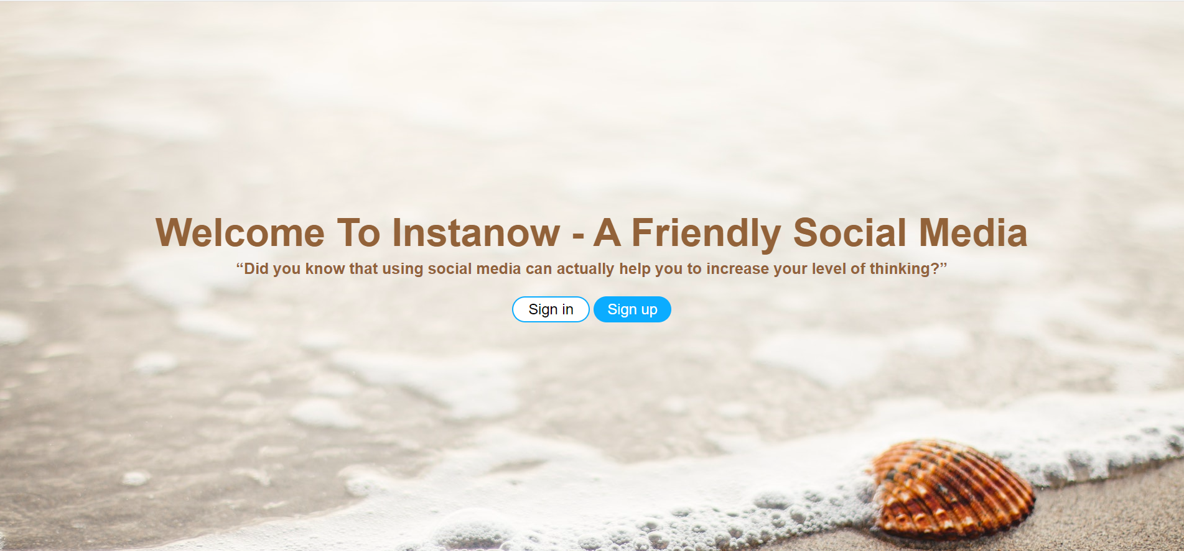

**Figure 6.1: INDEX PAGE SCREENSHOT**

**6.2 VALIDATION**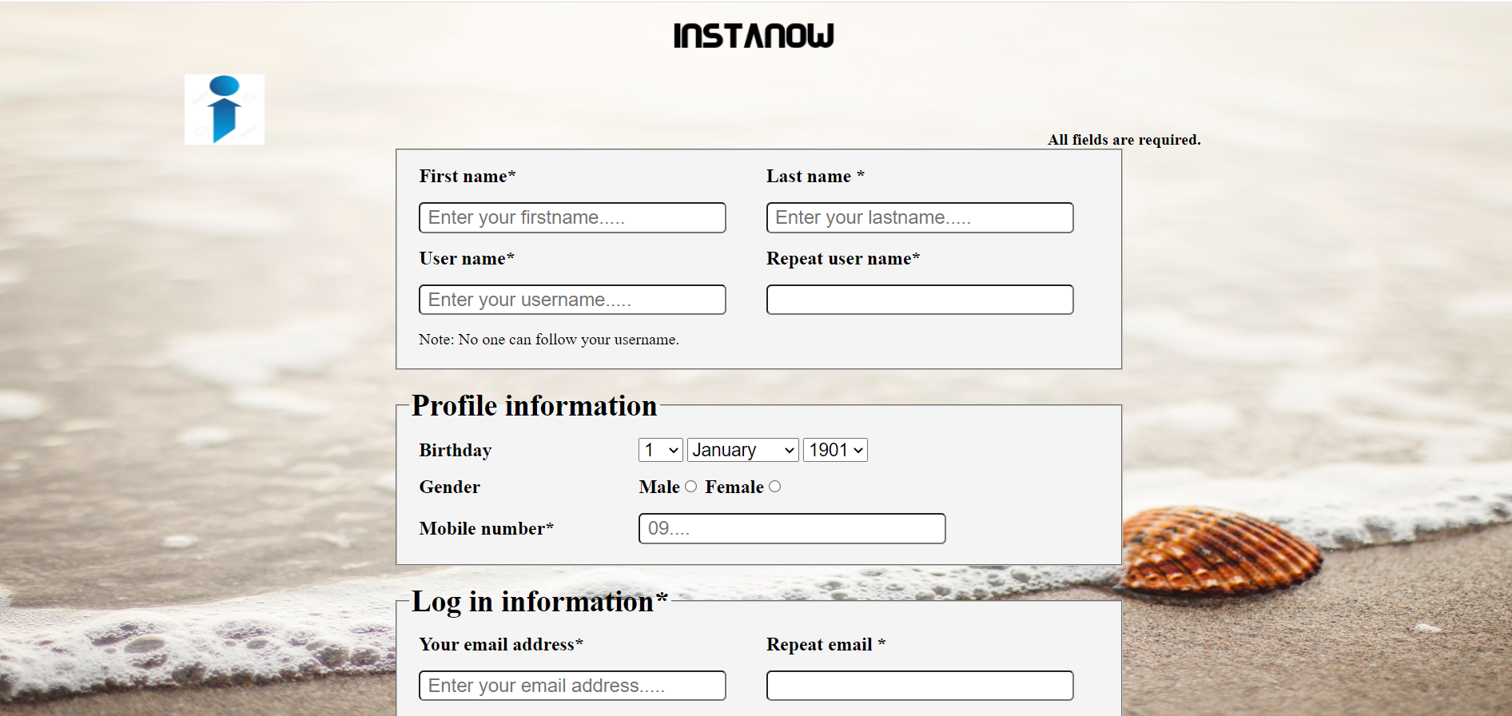

**Figure 6.2: SIGNUP SCREENSHOT**



**Figure 6.3: SIGNIN SCREENSHOT**

**6.3 HOME**

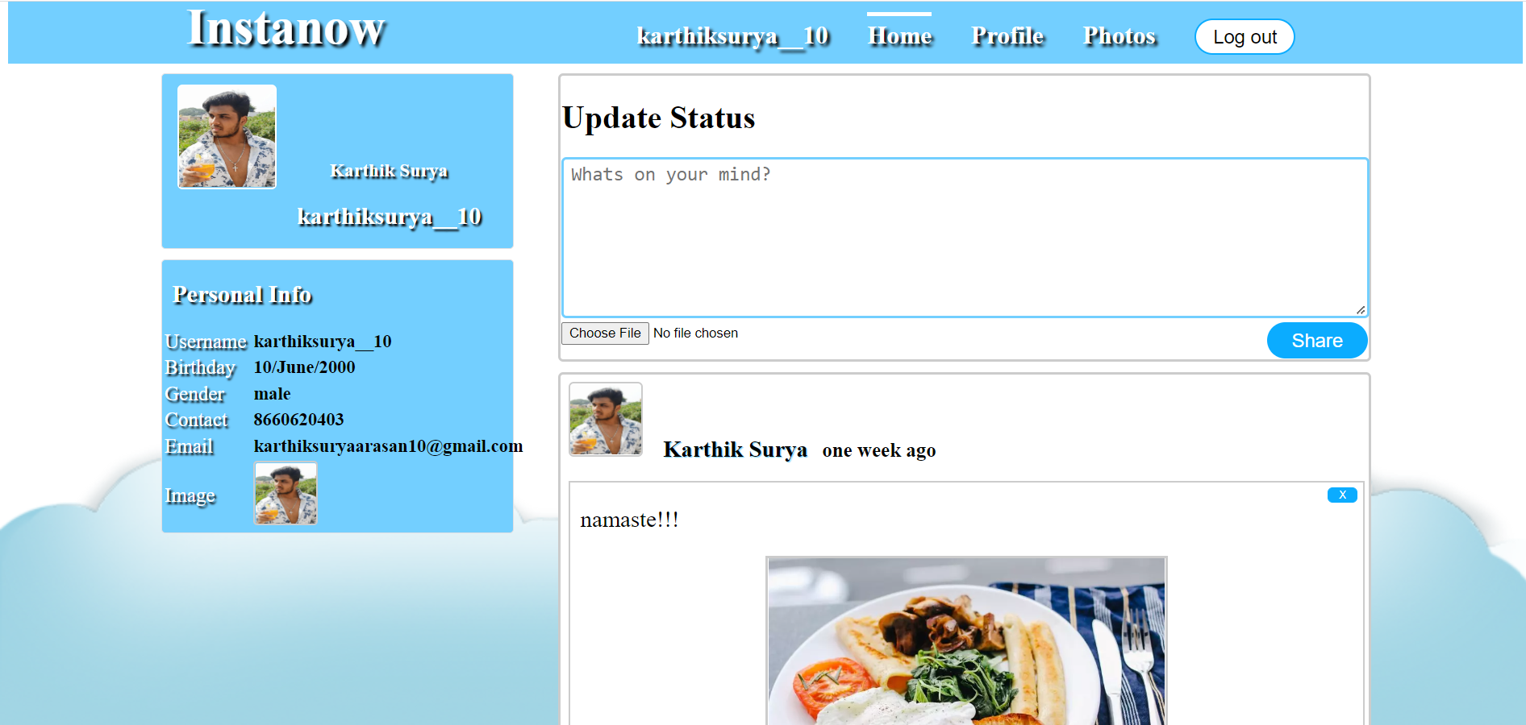

**Figure 6.4: HOME SCREENSHOT**

**6.4 USER_PROFILE**

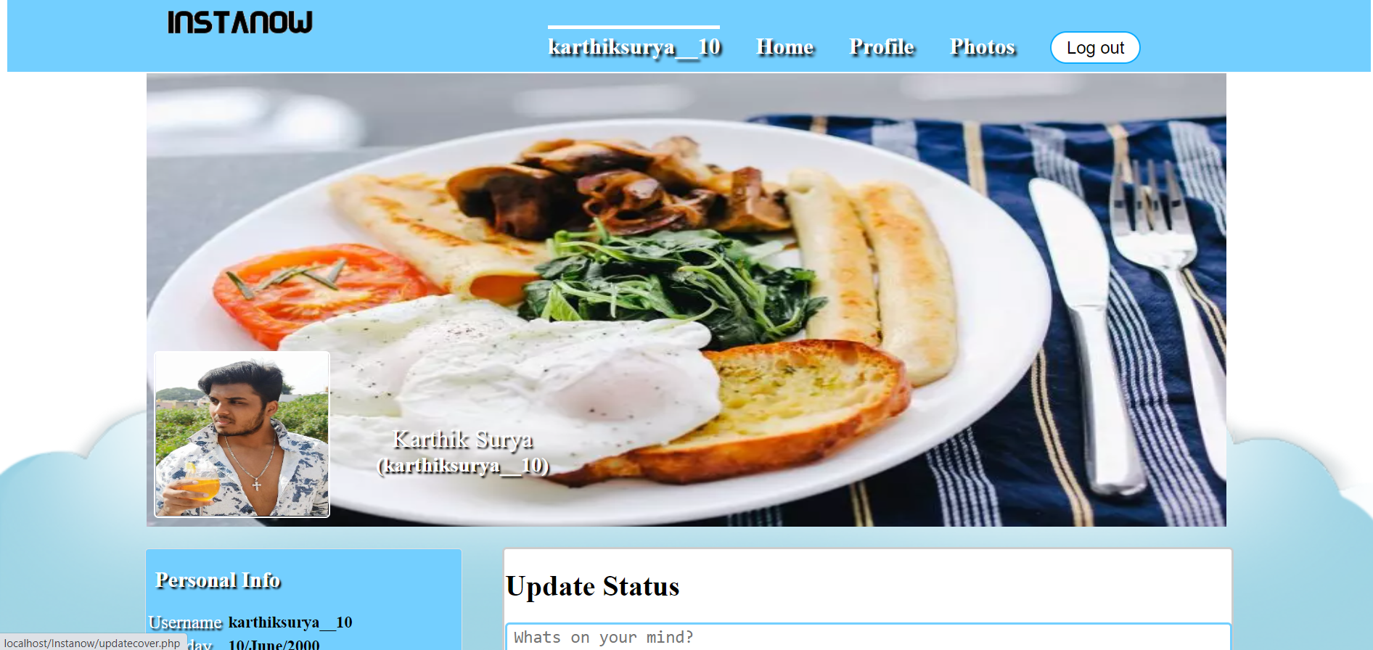

**Figure 6.5: USER_PROFILE SCREENSHOT**

**6.5 EDIT_PROFILE**

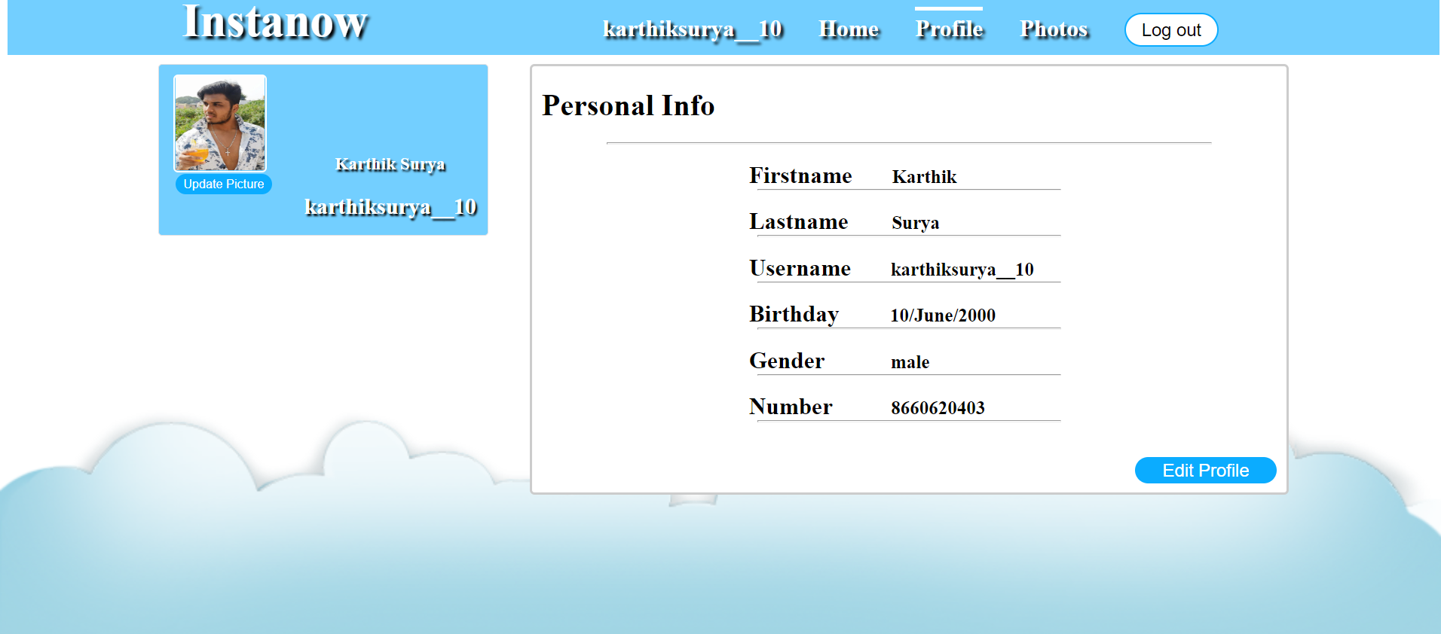

**Figure 6.6: EDIT_PROFILE SCREENSHOT**

**6.6 PHOTOS**

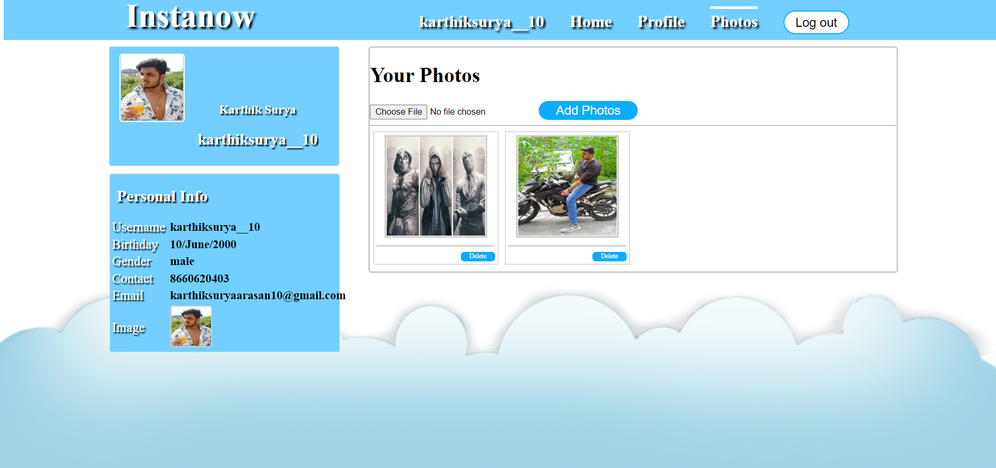

**Figure 6.7: PHOTOS_PAGE SCREENSHOT**

**CHAPTER 9**

**CONCLUSION**

This mini project has successfully accomplished the goals it had set out in the objectives and design sections of this report. I have also learnt many new concepts of web frameworks technologies and have used and implemented them successfully, and Visual Studio Code provides many options and is easy to understand and code. XAMPP database is also easily understandable and easy to work with.

Social media may be a truly helpful and critical communication network for all the individuals these days. Able to use it to know companions and keep contact with companions that came from diverse nations. Able to moreover share our thoughts so rapidly that all the things might create so quickly since individuals seem to tell us their thoughts and we seem to move forward promptly. We might too learn unused things on social media by observing or perusing the things that individuals shared onto the social media. People could too offer things on social media unreservedly which might diminish the consumption of notices. There are more points of interest for utilizing social media, however, there's continuously points of interest and disadvantages for a thing. As social media is as well helpful for individuals, nearly most of them do not indeed have to be 'speak out' to communicate with individuals. Nowadays, individuals will misplace their communication aptitudes. The more genuine issue is numerous individuals used the control of social media and utilized it to bully somebody.

**REFERENCES**

Are Social Networking Sites Good for Our

Society?”

ProConorg Headlines. N.p., n.d.

25, April 2013.

Powered by TCPDF ()

Conner, Cheryl. "Employees Really Do Waste Time at Work." Forbes. Forbes Magazine, 17 July

2012. 25, April 2013.

Gesenhues, Amy. "Social Ad Revenue To Grow 18.6% By 2017 [Report]." Marketing Land. N.p.,

n.d. 25, April 2013.

"Internet Usage Reports - Internet World Stats." Internet Usage Reports - Internet World Stats.

N.p., n.d. 25, April, 2013.

Jerpl, Laura. "Political Campaigns and Social Media - Tweeting Their Way Into Office." Political

Campaigns and Social Media - Tweeting Their Way Into Office. N.p., n.d. 25, April 2013.

Lister, Tim. "Tunisian Protests Fueled by Social Media Networks." CNN. Cable News Network,

12 Jan. 2011. 25, April 2013.